**Create an EC2 Instance Using an Ansible Playbook**

**Prerequisites**

1. **Ansible Installed**: Ensure Ansible is installed on your system.
2. **AWS Credentials Configured**: Configure AWS credentials using the AWS CLI or set them as environment variables.

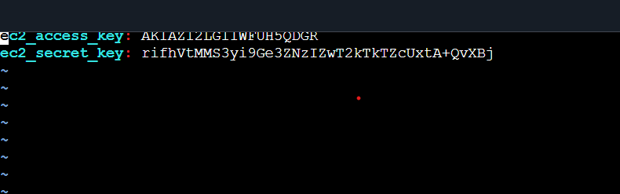

1. **Python Libraries Installed**: Install boto3 ,if not already available.
2. **IAM Permissions**: Ensure your AWS credentials have permissions to manage EC2 resources (e.g., ec2:RunInstances).

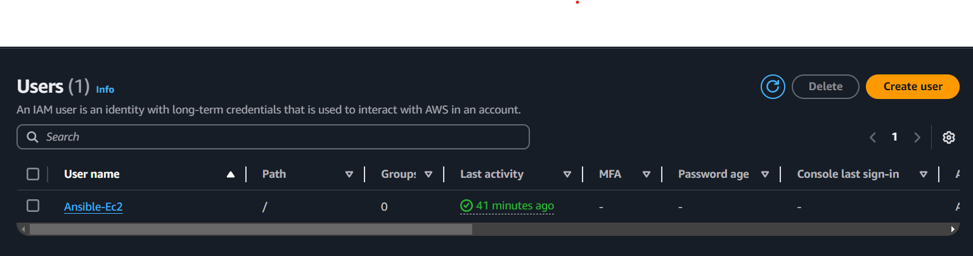

**Step 1: Install AWS Ansible Collection**

Ansible uses the AWS modules from the amazon.aws collection. Install it with the following command:

ansible-galaxy collection install amazon.aws

**Step 2: Create the Ansible Playbook**

Create a file named ec2-create.yml with the following content:

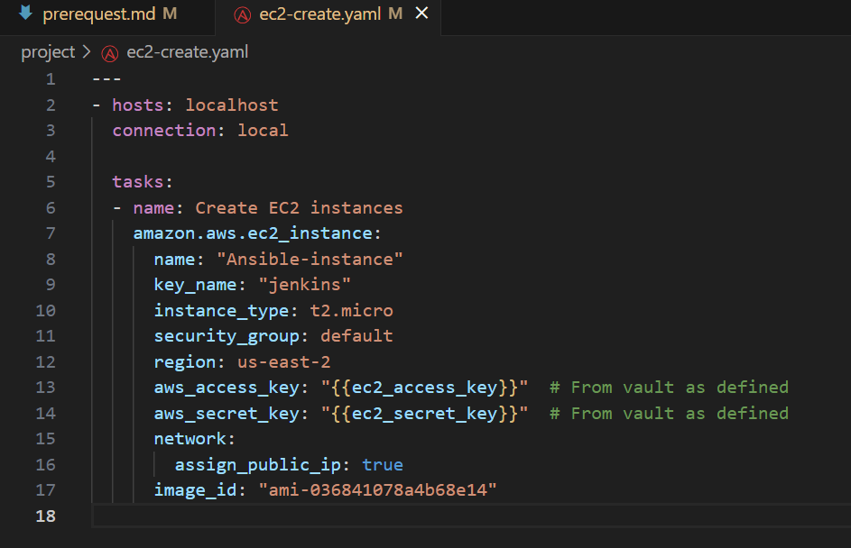

**Explanation:**

* name: Name of the EC2 instance.
* key_name: The name of your EC2 key pair for SSH access.
* instance_type: The type of EC2 instance (e.g., t2.micro).
* image_id: The AMI ID to launch the instance (specific to your region).
* region: AWS region where the instance will be created.
* security_groups: List of security groups associated with the instance.
* state: present ensures the instance is created; use absent to terminate it.

**Step 3: Execute the Playbook**

Run the playbook using the following command:

ansible-playbook -i inventory.ini create_ec2.yml

**Step 4: Verify the Instance**

1. Log in to the AWS Management Console.
2. Navigate to **EC2 Dashboard** > **Instances**.
3. Verify the new instance is running.

